NACF Embodied Carbon Benchmarking
Pathfinder Initiative
Factsheet and FAQs V1.1
Introduction
The NACF Embodied Carbon Benchmarking initiative is a pathfinder project launched as a collaboration between the contractors and operators of the Southern Construction Framework (SCF) and the SCAPE national construction frameworks. The data collection tool was developed as a prototype by the SCF and then, in collaboration with SCAPE further developed and digitised during 2022 and launched with an online data entry form in December 2022.
Participation in the initiative is open to, and encouraged for, all framework contractors / operators within the NACF community who are delivering construction (ie building) projects covering both new build and retrofit/refurbishment activity.
The initiative will provide a data collection and database tool built in collaboration with the carbon management leads of contractors who have a collective will to share the learning and best practice that can most quickly enable us to reduce embodied carbon in our public sector buildings. Simply put, we all want to know what good looks like, and we all want to accelerate towards lower carbon projects as soon as possible.
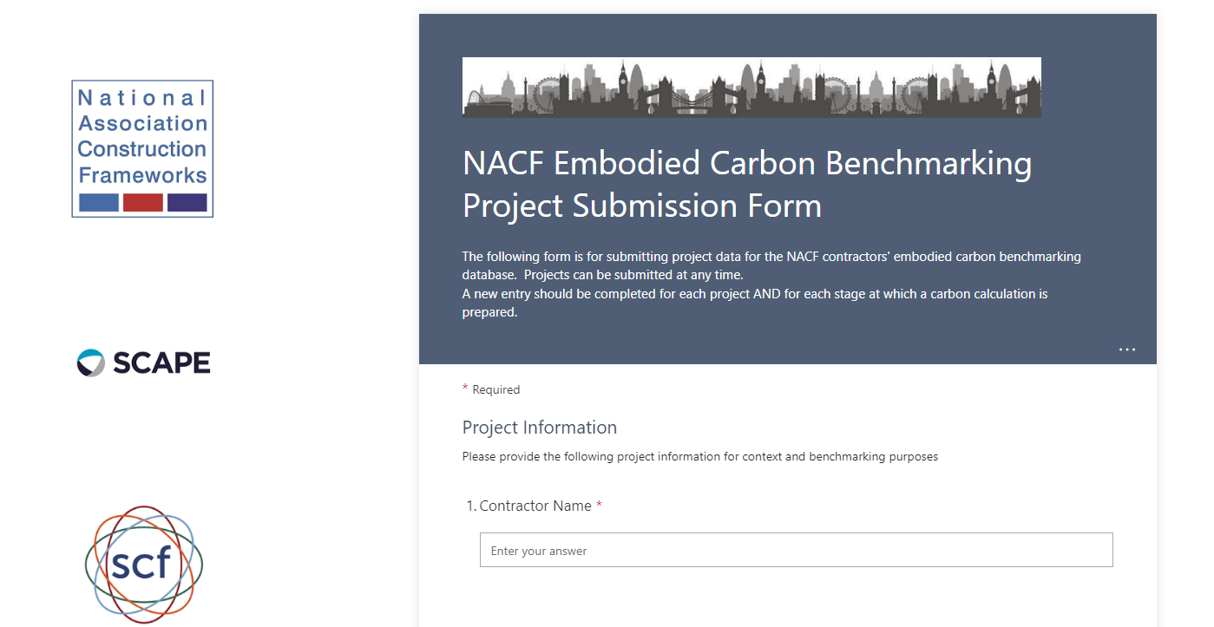

Contact
For questions about participation, please contact one of the NACF Sustainability Co-convenors:
Kingsley Clarke, Southern Construction Framework Kingsley.clarke@devon.gov.uk
Chris Clarke, SCAPE chrisc@scape.co.uk

What is the purpose of the initiative?
Embodied carbon emissions account for 12% of UK greenhouse gas emissions. More than the domestic air traffic and shipping industries combined.
The NACF Embodied Carbon Benchmarking initiative aims to rapidly build an accessible and useful dataset of project embodied carbon emissions that can be used to identify approaches that reduce embodied carbon quickly and to track the progress of the NACF community in delivering a more sustainable UK construction sector for our clients.

What is the scope of the benchmarking data?
Our focus is on embodied carbon and specifically, within the PAS 2080 / RICS code of practice structure:
- Scope A1 to A3 or cradle to gate emissions – the emissions arising from the raw material extraction, transport and manufacture of building products and off-site assemblies.
- Scope A5, Construction and installation emissions – the emissions arising from the activities of the contractor and subcontractors, including site electricity, water and fuel use-age.
Data can be supplied at any stage of the project delivery process; from evaluation of an initial scheme design, to tender stage and on completion of construction. Data can be submitted at multiple project stages for the same project; with the RIBA stage captured with each submission. We only collect Scope A5 data – construction emissions - after works have been completed.
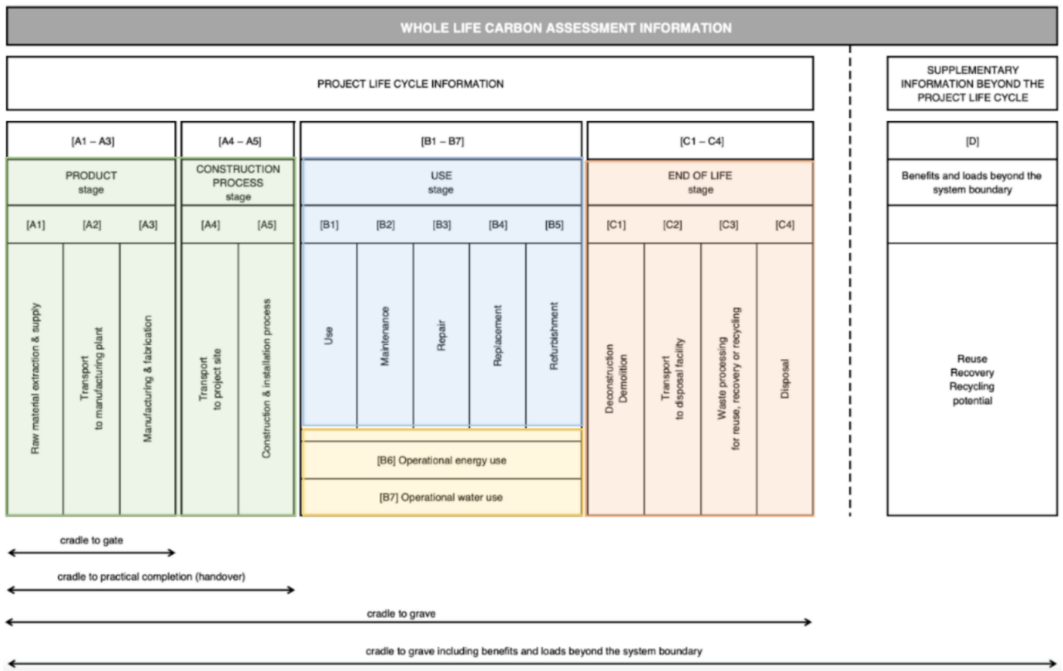

Which organisations can take part?
The NACF Embodied Carbon Benchmarking Initiative is open to:
- Participating NACF member framework operators
- Main contracting organisations appointed by participating NACF framework operators
- Associate organisations, identified through NACF invitation only

Who is already involved?
The NACF Embodied Carbon Benchmarking Initiative is currently being supported by:
NACF Framework Operators | Contractors
Southern Construction Framework  SCAPE  NWCH – Roll out planned  CWM – Roll out Planned  YORHub – Roll out Planned | MACE Construct  BAM  John Sisk and Son  Kier Construction  Willmott Dixon Construction  Morgan Sindall Construction  McLaughlin and Harvey Construction*  Graham Construction*  Galliford Try  Wates Construction*  ISG*
*pending introductory briefings
In Spring 2023, the Infrastructure and Project Authority is joining this benchmarking group and supporting consistency of our approach with wider central government plans.
Does this duplicate the RICS led Built Environment Carbon Database (BECD)?
The BECD is recognised by the NACF as a crucial tool for the future in building a comprehensive picture of whole life carbon emissions arising from buildings and construction. Once available and fully accessible this tool will give industry wide consistency and quality of data.
However, the BECD database is necessarily taking time to construct and deliver and will also be a complex and technically demanding tool to maintain and utilise. The NACF community of construction carbon managers have identified we need useable information and benchmarks on embodied carbon urgently, and specifically information on those areas we can influence and control quickly.
The NACF database could be seen as a forerunner and a subset of the BECD; that is available and useful NOW for those motivated to start taking rapid action.

Is participation in the benchmarking initiative mandated by all framework operators in the NACF?
No, although some operators may choose to mandate use of the tool over time. In the short term, participating framework operators are making reference to the database both informally and eventually formally in their Framework Agreements to encourage participation by their contractors. We want rapid uptake, growth of the data set and for use of the data to be made in practice.

What are the benefits for participants?
The are a number of benefits for participants:
- Shared learning – all participants are taking part and contributing information to ensure learning about the approaches that successfully reduce embodied carbon is quickly shared across our industry
- Evidence base for improvement – sharing project data now gives us a clear baseline to track collective progress towards a lower carbon future and the ability to compare each or our organisations progress against the wider community of practice.
- Demonstration of commitment and participation in cutting carbon emissions –
The NACF is committed to the use and promotion of the Construction Leadership Council’s Carbon Reduction Code – a holistic code of practice with three tiered levels of compliance which recognise organisational commitment and progress towards decarbonising the UK construction sector. Participating in this benchmarking initiative has been recognised by the Carbon Code steering group as a relevant and recognised activity in supporting code applications and also sits well as part of construction companies bidding activities to public sector clients; being well aligned to the principles set out in the Construction Playbook.

How do I get involved?
For NACF framework operators, please contact one of the sustainability convenors to register your organisational interest in participating in the embodied carbon initiative. There are a small number of administrative tasks to mobilise your framework to participate.
If you are a contracting organisation and wish to include project data in the benchmarking initiative, then you will first need to ensure your NACF framework operator has registered the framework to take part.
We will then make arrangements with your framework operator to provide training and guidance on submitting project data and using the benchmarking database once online.

Who can input data?
Data entry can only be undertaken by trained carbon management or sustainability professionals working for, appointed by or otherwise acting on behalf of an organisation that has signed up to take part in the initiative.

Who can use the data?
We hope to make the data widely available as quickly as we can, certainly within the participating organisations who have signed up to take part. The data is being compiled into an open access database for use by the NACF community of participating organisations.
Use of the benchmarking data will be strictly limited to the betterment of participating organisations, their projects and the wider industry; appropriate use is a condition of participation.
The NACF and participating framework operators and contractors may make reference to and use of the benchmarking data for their own promotional purposes with express prior consent.
We expect to produce a periodic benchmarking publication once the dataset is of a sufficient scale to identify and share trends in our collective activities. Participants will be given opportunities to contribute to this process with narrative and potentially case studies.

How is data protection and data quality managed and are the interests of clients of project considered?
Data submitted to the database is intentionally anonymised to avoid any data protection issues. Participants in the initiative are required to sign a simple information sharing declaration prior to participation.
Projects are identified by type of construction, scope, scale and regional location for comparative purposes. Participants can optionally provide the client organisation name with their consent.
Data quality is controlled through training and through sampling and peer review of data being supplied. We only provide access to submit data for benchmarking by identified, named and trained users to avoid risks of poor quality data. It is our community of users, who are construction sector carbon managers, who are central to data quality management.

Where is data being stored and how?
Data submitted for benchmarking is being managed and stored on behalf of NACF and participants in the benchmarking initiative by SCAPE.
All data is be stored in a secure and ringfenced cloud-hosted server environment. SCAPE is accredited to the UK Cybersecurity Essentials standard. Data is only retained for the purposes for which it is supplied.

